ORDER FORM Page 1
Order Number: PEL/AND 6.20(Oxford) Blue and White Oxford Button Down (UPDATE2/7) Date: 24th June 2020
Company: ANDRUM S.n.c Via Spartaco, 50 Andria (Ba)
Product: Men’s shirts Details: Button down – Blue & White Stripe
Collar | Cuff | Buttons and button holes | Fit | Front | Back | Labelling
Soft (morbido?) lined button down collar  BD173  9cm  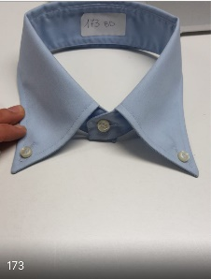  Burgundy piping  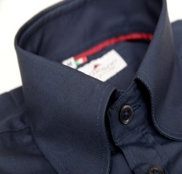 | 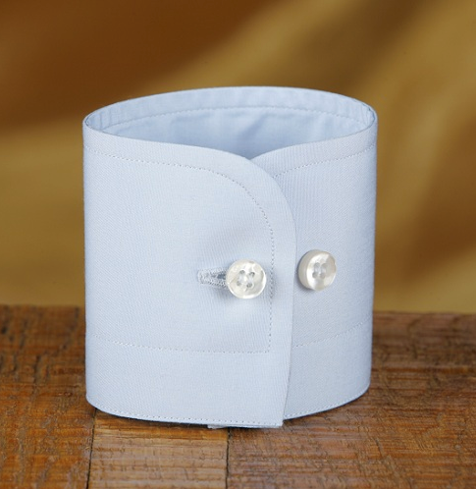 | Buttons:  White Mother of pearl  Thread : white  Button Holes : white  Button holes: ONE burgundy at the bottom  Bottom button hole – burgundy (Button hole number 8 in photo) and 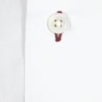  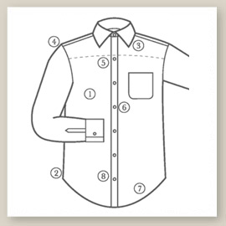  Cuff button hole - burgundy | Slim fit  And regular fit | Front placket  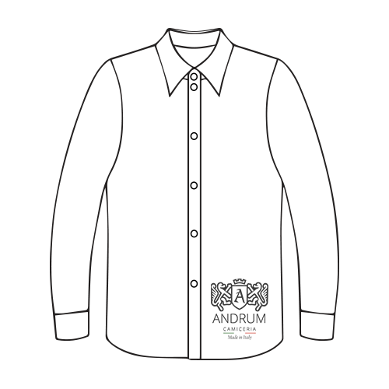  Pocket  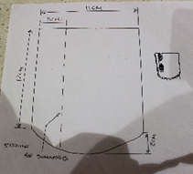 | 2 Central folds  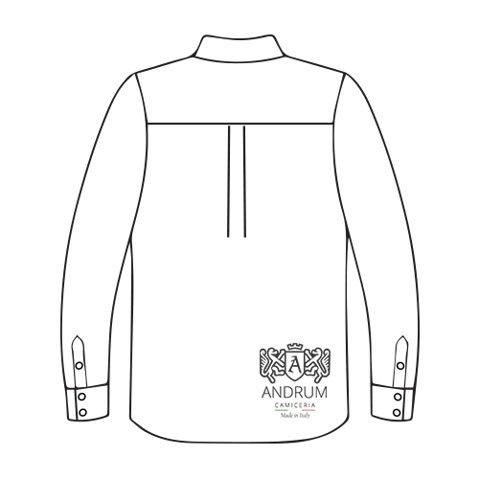  Locker hoop  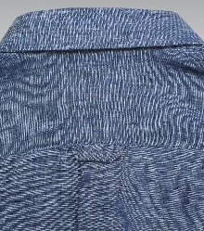 | 1 to the back of shirt  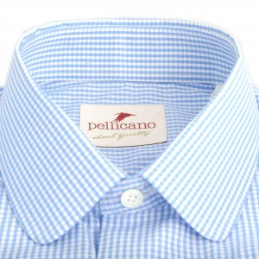  2 side gusset triangular labels

Page 2
Order Number: PEL/AND 6.20 (oxford) – Blue & White Stripe Button Down (UPDATE 2/7)
Date: 24th June 2020
Details:
Button down
Fabric, Sizes and Quantities
Shirt Fabric | Small | Medium | Large | X large | XX large | Total
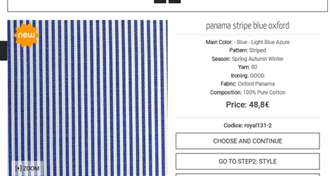 | Reg: 0  Slim: 1 | Reg: 2  Slim: 3 | Reg: 2  Slim: 2 | Reg: 2  Slim: 3 | Reg: 1  Slim: 2 | Reg: 7  Slim: 11

